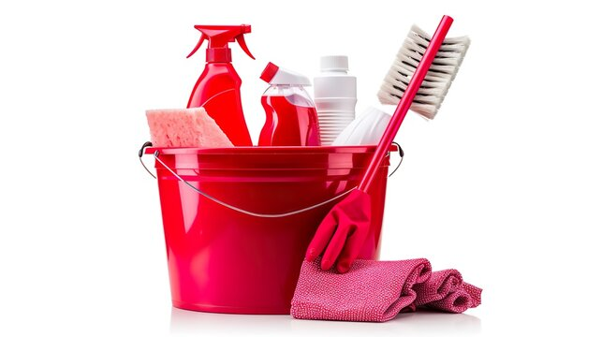

Preparing for
Spring Hall Closing!
Non-Graduating Student Halls Close:
FRIDAY, MAY 8, AT 11AM
*All-non-graduating residents must depart 24 Hours after their LAST final exam
Graduating Student Halls Close:
SUNDAY, MAY 10, AT 11AM

THINGS TO DO BEFORE YOU CHECKOUT
Make sure you…
- Attend your RAs Closing Meeting & Schedule your checkout appt. with your RA
- Pack all your items… Be sure to check drawers & closets!
- Defrost and clean your microfridge
- Remove all trash & recycling
- All belongings must be removed from your room before your checkout appointment.
- Set thermostat appropriately to 72-75 Auto-Setting
- Turn lights off, close window blinds.
- Lock the door behind you and return your key to drop box in your residence hall or to Security in Ponce or the Commons
  - Failure to return your key will result in a charge. We will not accept late or keys mailed in after move-out!

WHAT IS A CLEAN ROOM?
  - Remove posters & decorations from walls
  - Empty closets, desks, & drawers
  - Windows should be clean and free of curtain rods, etc
  - Furniture wiped down, including the inside of drawers, desk top
  - Sweep floor & mop, if necessary
  - Clean the bathroom: shower, sink, toilet bowl
  - Properly disposed trash & recycling

REMINDER: 24 HOUR QUIET HOURS MAY 1ST 10PM-HALL CLOSING
The Residence Life Team will perform the final damage assessments with College Facilities Team and you may be subject to damage and cleaning charges for improper check-out procedures.

